Practice 5

1. Write a query for the HR department to produce the addresses of all the departments. Use the LOCATIONS and COUNTRIES tables. Show the location ID, street address, city, state or province, and country in the output. Use a NATURAL JOIN to produce the results.

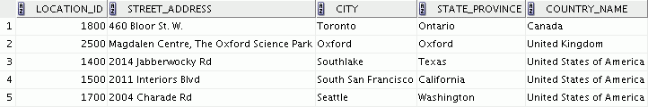

1. The HR department needs a report of all employees. Write a query to display the last name, department number, and department name for all employees.

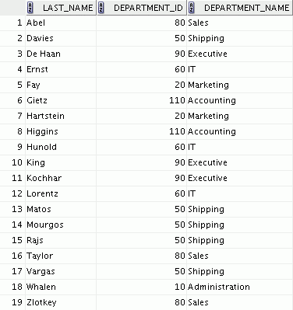

1. The HR department needs a report of employees in Toronto. Display the last name, job, department number, and department name for all employees who work in Toronto.



1. Create a report to display the last name and employee number of employees along with their manager’s last name and manager number. Label the columns Employee, Emp#, Manager, and Mgr#, respectively. Place your SQL statement in a text file named lab_05_04.sql.

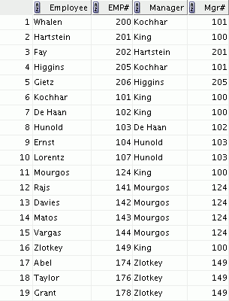

1. Modify lab_05_04.sql to display all employees, including King, who has no manager. Order the results by the employee number. Place your SQL statement in a text file named lab_05_05.sql. Run the query in lab_05_05.sql.

# …

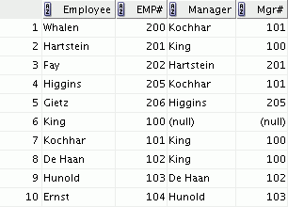

1. Create a report for the HR department that displays employee last names, department numbers, and all the employees who work in the same department as a given employee. Give each column an appropriate label. Save the script to a file named lab_05_06.sql.

# …

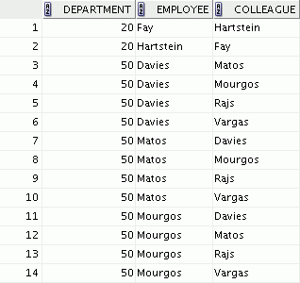

1. The HR department needs a report on job grades and salaries. To familiarize yourself with the JOB_GRADES table, first show the structure of the JOB_GRADES table. Then create a query that displays the name, job, department name, salary, and grade for all employees.

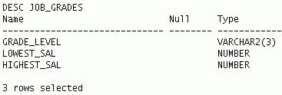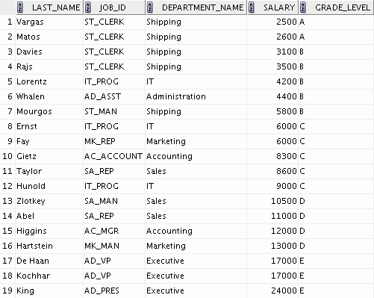

If you want an extra challenge, complete the following exercises:

1. The HR department wants to determine the names of all employees who were hired after Davies. Create a query to display the name and hire date of any employee hired after employee Davies.

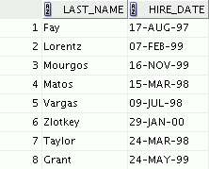

1. The HR department needs to find the names and hire dates for all employees who were hired before their managers, along with their managers’ names and hire dates. Save the script to a file named lab5_09.sql.

